**Submission Form**

**Fill up the following slots with appropriate content. You must submit the content of this document from this page only.**

1. Your Name: Mohammad Shafkat Hasan
2. Your ID: 19101077
3. Your Section: 04
4. Experiment No: 01
5. Experiment Title: Verifying the inverse square nature of Coulomb's law and determining the value of Coulomb's constant, “k”.
6. **You must write your ID in each of the graphs you insert here.**
7. **Table 1**: both charges are **positive**

$$Q_{1 }=10 μC$$

$$Q_{2 }=10 μC$$

|  |  |  |  |  |  |
| --- | --- | --- | --- | --- | --- |
| **Sl:** | Distance ***r (meter)*** | $$log(r)$$ | $$\frac{1}{r^{2}}$$ | Electrostatic force ***FE*** |  |
| 1. | 0.014 | -1.853871964 | 5102.040816 | 4585.485 | 3.661385277 |
| 2. | 0.02 | -1.698970004 | 2500 | 2246.888 | 3.351581425 |
| 3. | 0.03 | -1.522878745 | 1111.111111 | 998.617 | 2.999398955 |
| 4 | 0.04 | -1.397940009 | 625 | 561.722 | 2.749521433 |
| 5 | 0.05 | -1.301029996 | 400 | 359.502 | 2.555701311 |
| 6. | 0.06 | -1.22184875 | 277.7777778 | 249.654 | 2.397338529 |
| 7. | 0.07 | -1.15490196 | 204.0816327 | 183.419 | 2.263444321 |
| 8. | 0.08 | -1.096910013 | 156.25 | 140.43 | 2.147459896 |
| 9. | 0.09 | -1.045757491 | 123.4567901 | 110.957 | 2.045154706 |
| 10. | 0.1 | -1 | 100 | 89.876 | 1.953643736 |

1. **Table 2:** one of the charges are positive and another is negative.

$$Q_{3 }=1μC$$

$$Q_{4 }=-1μC$$

|  |  |  |  |  |  |
| --- | --- | --- | --- | --- | --- |
| **Sl:** | Distance ***r (meter)*** | $$log(r)$$ | $$\frac{1}{r^{2}}$$ | Electrostatic force ***FE*** |  |
| 1. | 0.014 | -1.853871964 | 5102.040816 | 45.855 | 1.661386698 |
| 2. | 0.02 | -1.698970004 | 2500 | 22.469 | 1.351583744 |
| 3. | 0.03 | -1.522878745 | 1111.111111 | 9.986 | 0.999391562 |
| 4 | 0.04 | -1.397940009 | 625 | 5.617 | 0.749504424 |
| 5 | 0.05 | -1.301029996 | 400 | 3.595 | 0.555698895 |
| 6. | 0.06 | -1.22184875 | 277.7777778 | 2.497 | 0.397418542 |
| 7. | 0.07 | -1.15490196 | 204.0816327 | 1.834 | 0.263399331 |
| 8. | 0.08 | -1.096910013 | 156.25 | 1.404 | 0.147367108 |
| 9. | 0.09 | -1.045757491 | 123.4567901 | 1.11 | 0.045322979 |
| 10. | 0.1 | -1 | 100 | 0.899 | -0.046240308 |

1. Draw $F_{E}$ vs $r$ graph that is you plot $r$ along the $x$ axis and $F_{E}$ along the $y$ axis. For two tables you will get two curves. You can draw into one curve if you want. Insert the **graph-1** as image here:

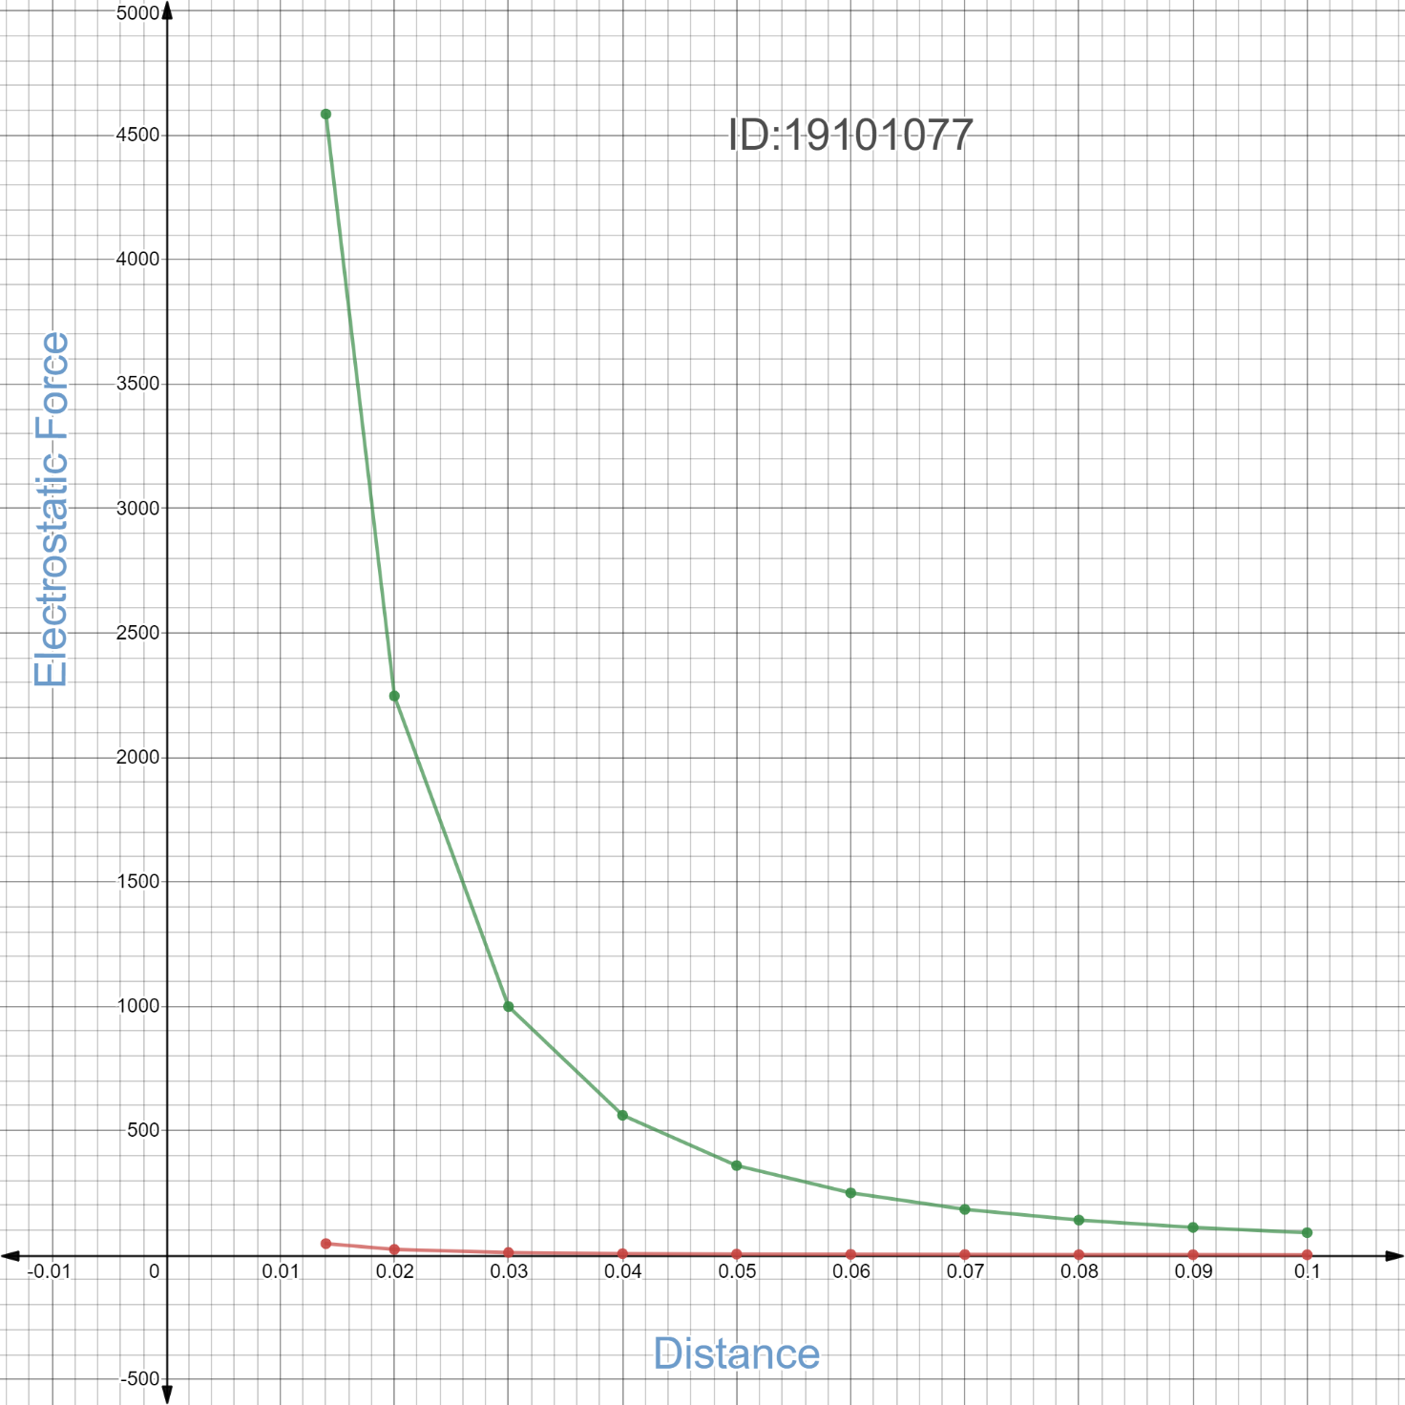

1. Draw $log(F_{E})$ vs $log(r)$ graph that is you plot $log(r)$ along the $x$ axis and $log(F_{E})$ along the $y$ axis. For two tables you will get two lines. Find the slope from both of the straight lines you get.

Slope from line 1: 1.61246

Slope from line 2: -0.387517

Mean slope: 0.6124715

Insert the **graph-2** here:

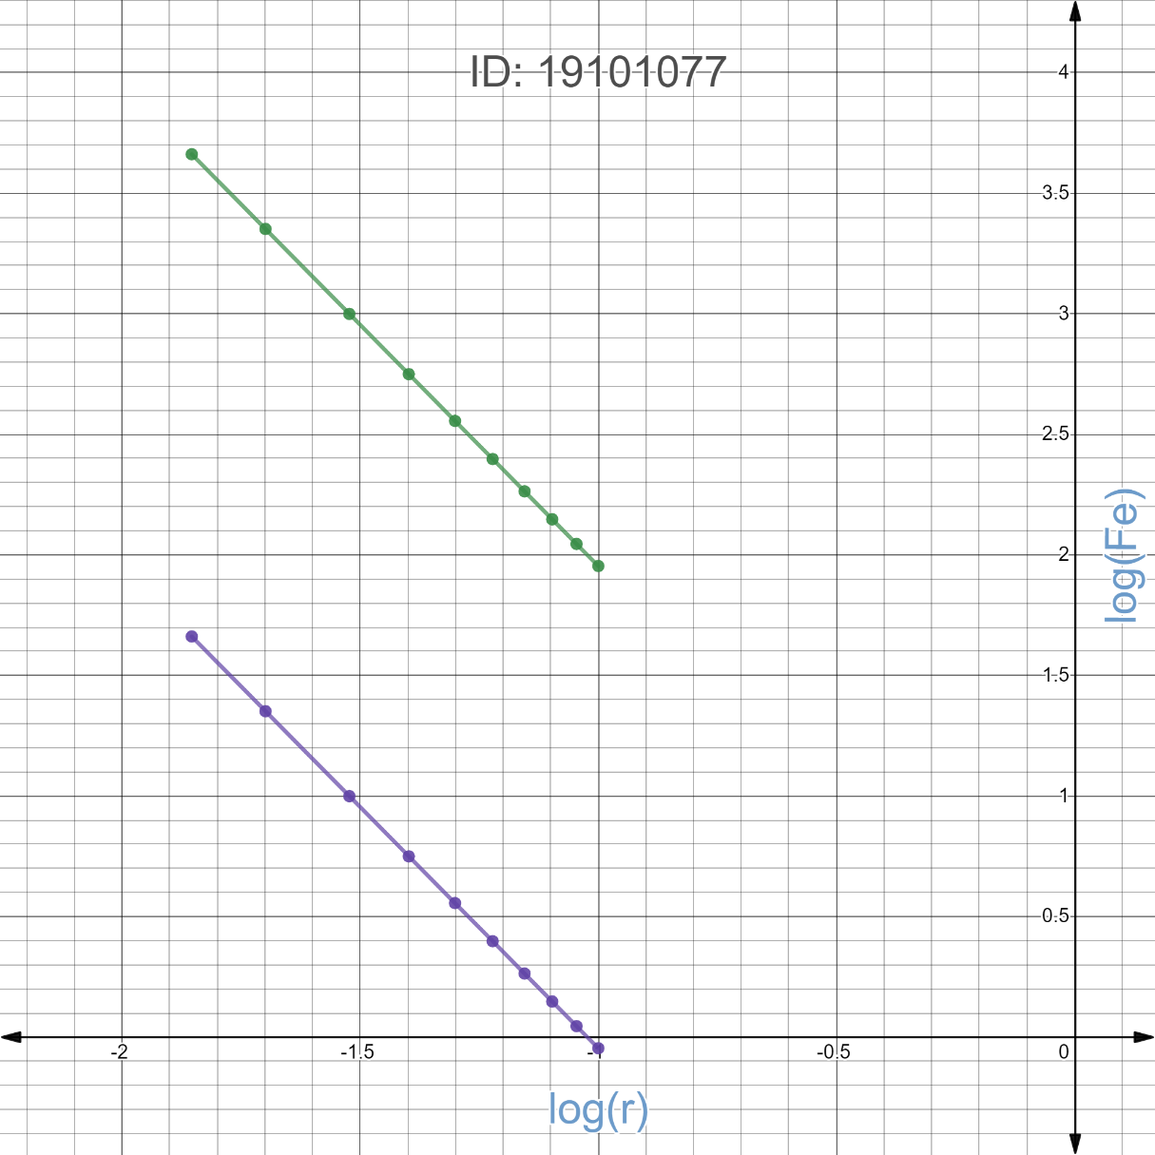

1. Draw the Electrostatic Force, $F_{E}$ vs inverse square distance, $1/r^{2 }$ curve. You plot $1/r^{2 }$ along the $x$ axis and $F_{E}$ along the $y$ axis. You will get two straight lines for each table. Find the slope of each line.

Slope from line 1: 0.898755

Slope from line 2: 0.00898757

For each table you have different $Q_{1}$ and $Q_{2}$. Calculate $k$ for each table:

$$k_{} = slope / (Q_{1}Q_{2})$$

$k$ from line 1: 8987550000

$k$ from line 2: 8987570000

Mean $k$: 8987560000

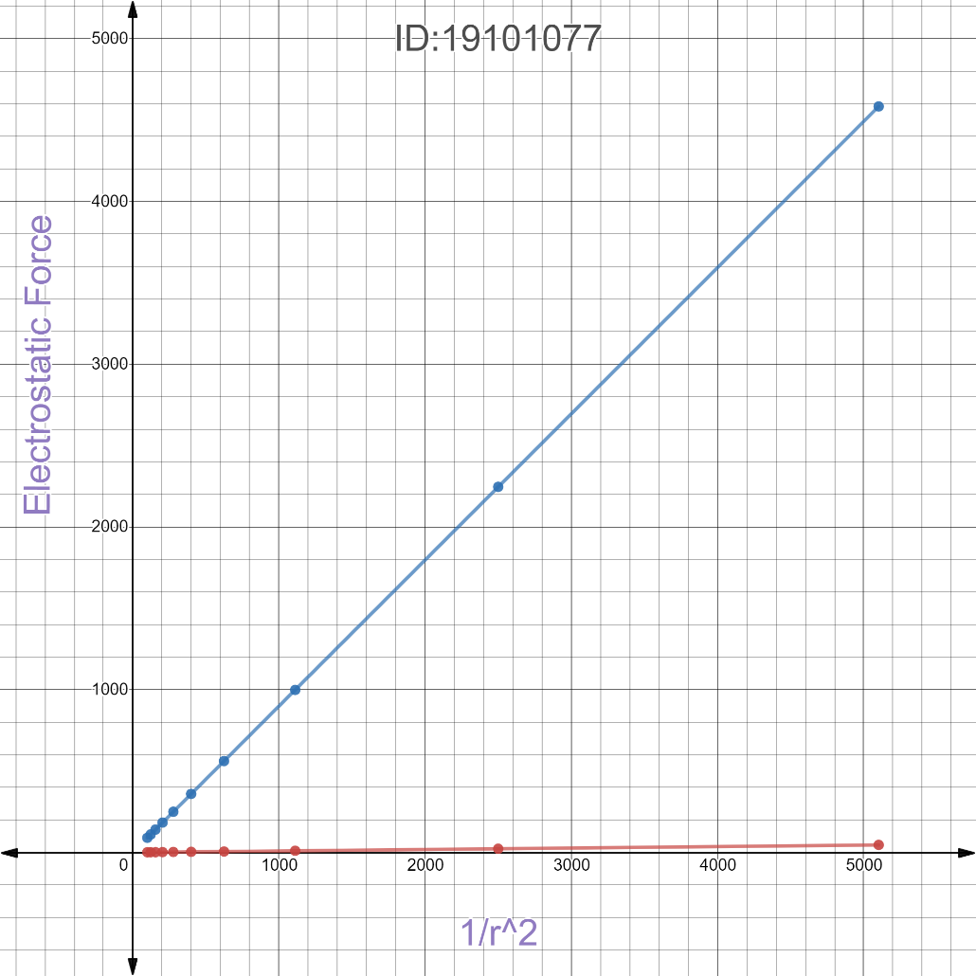Insert the **graph-3** here:

1. **Please briefly** discuss how the process of taking logs allows to find the inverse squared nature of Coulomb force and anything related to this experiment that you found interesting.   
     
   You are ***strongly*** encouraged to use your **own words** to describe your thoughts. **However, any kind of plagiarism (such as copying and pasting from other students’ lab-reports) will not be tolerated and will be subject to disciplinary action according to BracU policy.**

**Discuss here:**

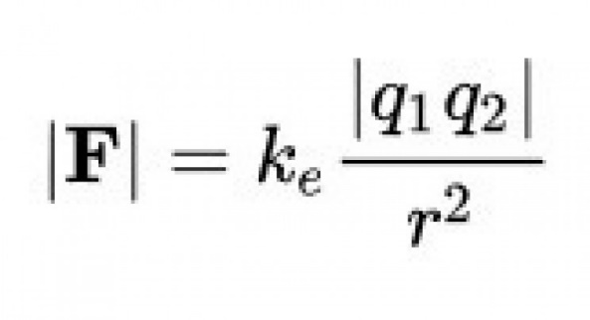Coulombs’ law is,

By taking logs, we got a graph of straight lines.

In my experiment k of line 01 and 02 is almost similar witch is really easy to calculate.

Making graph through Desmos is also very fun.